THRESHOLDS IN THE HOSPITAL: EMBROIDERING STORIES, WRITING MEMORIES

ABSTRACT:
This article presents the narratives of the methodological strategies of a research-intervention, developed in three stages, from 2015 to 2018, from the arrival of the team on the sidewalk of a general hospital in Porto Alegre (RS) to the meeting with the Sector of Pain and Palliative Care as a partner to develop a working device named Atelier Jardim de Histórias (Garden of Stories Atelier). The device invited patients diagnosed with chronic pain to share stories, their own or the world's, real or fabricated, through inscription surfaces (boxes, towels) for these stories. The establishing of the intervention-research's format took place over an extended period of time, listening to the hospital context for at least two years, until the unveiling of a format that had free embroidery on a hospital stretcher as a mediator of dialogue. The research bet/hypothesis is that, by offering an inscription surface like a towel, it produces the passage ways so that the pain, signified as only organic, moves on to another register of meaning, a more symbolic one. While embroidering, patients narrated their stories and inscribed fragments of their memories on the towel, a singular record through the Way of Word. The foundations of the research-intervention have theoretical inspiration in Walter Benjamin, in the psychoanalysis of Freud and Lacan, in addition to the Contextual Art of Paul Ardenne. It is a work woven by many hands and theoretical threads that lead to the idea of “weaving with the other”, in a bet that the establishing of practices in the relationship between subjects and different fields of knowledge can contribute to humanized health care.
Keywords: Narratives. Health. Art. Psychoanalysis. Education.

INTRODUCTION

In a small room, almost at the back of the hospital, people coming from different places from the metropolitan region of Porto Alegre (RS), with the most varied ages, embroider on a large towel spread on a hospital stretcher. Their common denominator is the fact that they all present a diagnosis of chronic pain, whose main symptom is persistent pain in multiple regions of the body. These patients were referred by professionals in the Sector of Pain and Palliative Care to participate in a research-intervention that aims to explore the relationship between narratives/fiction, stories that are told to someone with a willingness to listen, and humanized health care. Having a sewing box, colored threads, needles and a towel as work instruments in the treatment of chronic pain would be quite unusual if it weren't for the very story that led a UFRGS research team to build a work device - Garden of Stories Atelier - and implement it as a field of action.
The present text intends to narrate a singular path of this research-intervention until its implementation, telling the stories and strategies invented from the experience of approaching a very different universe from the one which the researchers were used to, articulating these strategies within the context itself and what was experienced in the unfolding field. To this end, three times/spaces of this trajectory, leading to different methodological strategies, stand out: the first one took place in 2015, on the sidewalk in front of the hospital which was the ground zero of the study, a time necessary to rehearse a way listening to the hospital and its demands. The second half included the years 2016 and 2017, when the Atelier started work near the hospital's garden and introduced a way to invite patients diagnosed with chronic pain to tell their stories. Yet the third time/space is located in the year 2018, when the group migrated to a room at the back of the hospital, in which the sewing box and towel became the triggering instruments of embroidered stories.
The lines that wove the foundations of the research-intervention were theoretically inspired by Walter Benjamin, in the psychoanalysis of Freud and Lacan, in addition to Paul Ardenne's Contextual Art; all of them being authors of different sewing boxes of knowledge and who did not personally dialogue with each other, but who produced a discussion triggered fundamentally by the research design and its protagonists, since the work is composed of different professionals and woven by many hands. The ethics of listening to the other and the validation of stories narrated in the face of different ways of perceiving the paths of life find in these theoretical perspectives an anchoring point, so that they led the research team to privilege the weave-with, a building in companionship as a means of contributing to humanized health care. Our research hypothesis included the wager that the establishing of conditions for the narrative/fiction to find a time/space for the weave-with contributed as an adjunct to the treatments. A hypothesis that was confirmed after all these times/spaces that took place between the years 2015 and 2018 and which also pointed to the threshold, a kind of fixed time or place of passage, which seemed to be an interesting position occupied by the team in front of others and that allowed the hospital to be shown a different way of relating to hurry, urgency and emergencies. Listening to the other is an availability to be expanded in a place such as a hospital. It requires another time. The urgency is for an ethics of being-with, a space devised to validate and listen to the words of the other.

1 BODY AVAILABILITY FOR THE THRESHOLD OF LISTENING

The sidewalk in front of one of the largest public hospitals of the city of Porto Alegre reveals a very particular and very democratic microcosm. There, street vendors of the most different types gather themselves closer, vying for a place between cars, buses, dogs, children, passersby and hospital users. Among the street vendors, there are those who sell socks, caps, speakers, toys etc., and even those who sell drinks, chocolates and fast food. The products seem to vary according to the weather of the day. For example, if it is a day is rainy, umbrellas are sold; if it is sunny, water is sold. The objects change, they adapt each time, but the selling strategy of informal trade is always the same: it takes into account the rush of people coming and going in that urgent space of life. It is a private organization, cadenced for a time of its own, which is the timing of the street, governed by the configuration of a space whose context is the edges/surroundings of health care.
In 2015, when the research team made the first approaches to the hospital - with the intention of knowing the intensity of the motions from there to, later, propose an intervention in order to collaborate with the field of health education, one of these street vendors on the sidewalk drew in attention. It was the only shop located with a fixed point, which never traded places and which seemed to be a point of reference for other traders and the people who circulated there. Because he was always standing on the sidewalk, something told us that this stand understood the flow of the hospital very well and would know how to tell us about the dynamics set in that region - after all, we were a team of foreign researchers, who did not constitute the institution's staff, and we needed, therefore, a gradual approach to understand what the place required as a possible intervention proposal. We decided then, that the entrance door would be next to this fixed street vendor, on the street, trying to form a hearing field that could bring us closer to the stories and the people who crossed - and sometimes stayed in - the hospital.
On a cloudy day and with a rain announcement, we stopped next to this fixed street vendor, which we discovered to be a famous Kachurrasco stroller - over time, we understand that Kachurrasco is the name given to a snack very similar to the popular “hot dog”, however, with a certain southern flavor: unlike the bread, sauce and sausage combo, it consists of a Gaucho version, typical of the state, stuffed with a large piece of roasted beef. This hybrid food that transits in between, being neither a hot dog nor barbecue, aroused our curiosity, since, besides the desire to learn a way to set up a fixed point and at the same time traveling in the hospital, we perceived ourselves as a “hybrid” team, formed by professionals from different fields of knowledge. At the beginning of the research, art, psychology and education contributed to the construction of a methodology specific to the new study context, although we had the principle of being situated in between the fields: neither one nor the other, a mixture; a certain shared hybridism characteristic of creative movements.
The Kachurrasco, which was at the main entrance of the hospital and was administered by two people, also seemed to be a kind of reference to other street vendors, functioning almost like a clock hand, indicating the turning of the gears and retail movements there. In that ground zero afternoon of the research, when the first raindrops started to appear, we established a nice conversation with the business owners, and as conversation goes, we feel authorized by the two merchants to park our also unusual street trade, the Wagon, a business of story buying and selling, nearby in our following trips to the hospital. This authorization was essential, as we noticed that the street, even though it is a public space, is regulated by market laws of the microcosm of a given space and tacit contracts between street vendors, which regulate the barter and trade relations. That is, in order to sell or exchange some merchandise, consent and authorization from the other street vendors that occupy the sidewalk are required, so that authorization is granted when the local street vendors feel that there is no risk of competition between establishments. To get to know the intricacies of this mechanism which is a part of the great gear that also makes up the life of the hospital, it took a few months, but the decision to spend an afternoon close to the street vendors, available to meet the stories and passersby who frequent the place, was related to the ethical need to feel the pulse of the street, to follow the details of the motions of the steps and the people, in an attempt to adjust our own steps to the pace of a rhythm proper to the subjects who frequent the place. It was a first attempt to put our bodies on availability to listen, while betting that the street could be generous to newcomers and tell us about the time/space we were trying to inhabit. The sidewalk there on the street bridged the gap, made up for a kind of passage, a necessary transition zone for a team coming from the university and already used to the work of teacher training to learn to listen to the reports of another context and to find the directions of the research among the corridors of the hospital.
In this space/time of passage, it was possible to hear many stories of pain, joy, healing, and suffering of passersby. However, the unusual happened in the middle of that afternoon, the one in which the rain had arrived and was already gone. We heard screams in the street and a certain crowd that stirred. One of the owners of the Kachurrasco stand approached and said, in a mixture of ecstasy and concern, that a robbery had happened nearby and the alleged thief, while carrying a knife, tried to sexually assault his victim, but the attempt had been frustrated and the burglar had been deterred by other street vendors - who had, in turn, arrested him inside a parking lot nearby. From the sidewalk, in an effort to follow with the eyes, ears, and the whole body, all the commotion of the core of that afternoon, it was convenient to listen to the voices, which, even when contradictory, made up the plot of a crime. Even if we had followed the shouting, the rush, the arrival of the police, we were not sure how to react, nor on how to pass that narrative forward in a coherent way. Had what we had heard, with our drifting bodies, actually happened? Had people's actions, in that story, been motivated by those reported intentions? In the midst of that stunned hearing of the bodies and the high speed speeches, we were required to remind – each other on the team – that what is attentive to research is above all the listening to something that is ordered/composed by fiction. That narrative literally caught us – by assault – and there, in the vortex of the event, it no longer mattered if it all existed as factual truth or not, after all, in Lacan's words, we bet that the “Truth has the structure of a fiction” (LACAN, 1956-1957/1995 p. 258-259).
The police arrived shortly after reporters were already announcing the incident. Cars, cameras, knives, sirens and weapons mixed together with the curious spirits of the population, who in an increasingly growing cry called for the lynching of the man trapped in the parking lot. The team stood there, without much apparent reaction, trying to adjourn any kind of opinion, almost as if we let the rhythm of the city unfold before our eyes, without wanting to understand its reasons. We had the impression that Brazil, that of Guimarães Rosa, was happening there.
From the first day of approaching the hospital, from the sidewalk, close to the street vendors, we could hear – and experience – that the work we were trying to propose, and that was yet to be drawn, with elements such as narrative, fiction, art, psychoanalysis, education and listening, would not be easy, as we would need to support a body, not only a physical one, but also a symbolic and political body, implicated and responsible for an ethics (LACAN, 1959-1960/1997); we would need time so that we could understand the urgencies and emergencies of that whole context. The pain, suffering and violence that went through the stories and events of that day, reaffirmed the importance of sustaining the presence; of proposing an research -intervention in which we kept open the wound of an unequal country, without the pretense of healing it. It became clear to us the importance of making differences exist and co-exist, to make them occupy a place on the sidelines, moving through the corridors fixing points, without letting them fixate us. An ambulant and hybrid way of researching and intervening. In the theoretical company of Walter Benjamin (BENJAMIN, 2018), we sensed, in some way, that it would be necessary to inhabit a territory on the threshold, to unveil a time in motion that would be able to hear the experiences without the rush to assume a result, that we would need to experience all the intensity of life, moreover making us protagonists of the stories we wanted to hear. In order to transmit the stories it was necessary to live them, tell them, write them.
In search of a listening position on the sidelines, from the sidewalk we jumped to a location a little closer to one of the hospital's entrance doors: in front of the emergency entrance. A place where people's speeds were even more accelerated and pausing to tell or listen to stories produced strangeness and curiosity. The image (Figure 1) became emblematic for the research team. Only afterwards, when looking at the photos produced for the research, did we notice the presence of a pay phone next to where we had fixed a temporary listening point. A pay phone, an object that represents the old way of communicating with those who are far away, seemed to be in accordance with a team that carried as technology precisely the art of telling and listening to stories as a powerful supporting device in health care.

Figure 1 – Image with the presence of a pay phone – temporary listening point
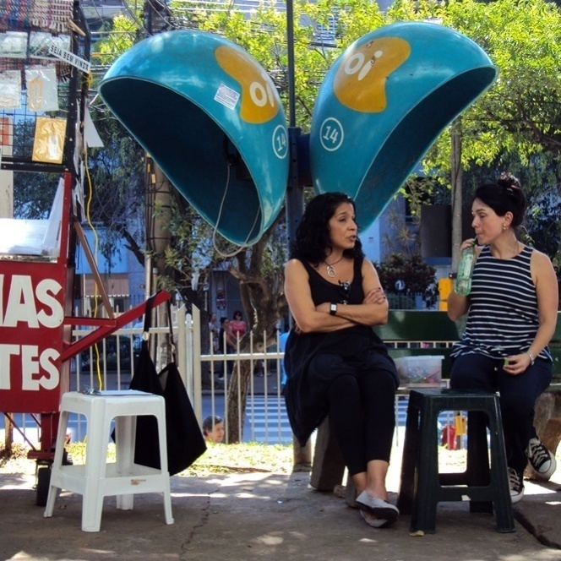
Source: researchers' personal archive

The inaugural movement of the research, the time of being available on the street, on the hospital's sidewalk, as a moment for the listening of this context, while open to be observant of any event – as manifested by the artists through their wanderings and happenings –, composed the first methodological step in the direction of formulating an intervention in the hospital with narratives/fiction. Standing still while observing, feeling the flows and motions of the intense comings and goings, paths and deviations, listening to people and being heard by them, telling stories and approaching the most extreme and radical differences, was the work's initial bet.

2 PAIN AND PALLIATIVE CARE AT THE GARDEN OF STORIES ATELIER

The team exercised the listening attitude initiated at the time of the sidewalk. And, in time, it entered the hospital. Or almost. First in the corridors, then following the arrows of the speeches indicating some direction. Was there any place there which could serve as a fixed/ambulant point to exchange stories? After the necessary wanderings and pivotal deviations, which started in 2015 and lasted throughout 2016, we found a point in the Sector of Pain and Palliative Care. There, the research team also felt heard and, more than that, felt questioned about the relation between narratives/fiction in health treatments. A psychologist from the Sector welcomed us and made the necessary line so that we could compose a fabric, raising the hospital's daily demands and acting as an interpreter of the times, languages and threads required to produce the research. In the Sector, the multiprofessional team collaboratively developed care strategies to alleviate the symptoms of patients with chronic pain, and also monitored patients and family members in end of life situations. It was with this team's partnership, in a work sector in which limit situations are everyday experiences – a place of threshold –, that we weave the design of a device aimed at patients with chronic pain, betting that a work with words could give the necessary substance to accommodate the suffering that pain imposes on bodies. Pain which is not known from where it arises or what causes it. This device was renamed Garden of Stories Atelier and launched its “stall” in 2017, in a small wooden house built in the garden, located outside the hospital, away from the hospital corridors that are, for our team, labyrinthine; also far from the Sector in which we would like to fix a stand, but, on the other hand, an important deviation from the center, a necessary travelling movement; a certain transit through the inside-outside of the hospital, essential for the work to happen. This space developed, for a long time, activities at the interface between art, education and health, becoming a reference for users and employees of the area, but had been disabled from its functions since 2016. It seemed to us that this was a great place to start activities, seeing as we would resume actions there that presupposed a confluence with what had already been done. The gesture of reopening the “house” and installing a device in this unusual geography of the hospital determined the way in which we built the triggers for the stories, since the place kept a memory of activities geared towards groups, workshops and art practices. Thus, the system that brought the work group together around a task was very similar to the operation of a workshop and was marked by the invitation for its participants to share stories: their own or the world's, real or fabricated. Crafted stories sparked by the encounters themselves, fictional narratives that could be triggered by an act that, as we betted, would challenge the message to circulate among the group and invite someone to take it for themselves. Our bet was that the narratives could constitute another surface for the inscription of pain, symbolizing what comes in the reality of the body.
The design of the intervention device was inspired by two other projects: Arte na Espera (Art in Waiting) and Armazém de Histórias Ambulantes (Store of Travelling Stories). Art in Waiting is a project developed at the Adolescent Health Center of the Clinics Hospital of the Federal University of Minas Gerais (HC-UFMG), through the project Janela da Escuta (Window of Hearing), in partnership with the Undió Institute, coordinated by artist Thereza Portes (CUNHA et al., 2015). The Store of Travelling Stories is coordinated by the artist Ana Flávia Baldisserotto, in partnership with the Free Atelier of Porto Alegre and the collective The Wagon. At the moment, these two projects, alongside Garden of Stories Atelier and Estudiantes a la Mesa (a project developed by artist Ana Laura de La Torre), make up the Hilo-Fio Network.
Guided by the ethics of psychoanalysis, by the contributions of Walter Benjamin, as well as by the theoretical constructions of Contextual Art by Paul Ardenne, we designed the research-intervention in order to place ourselves towards the sense of constituting a presence, a point in which our body weaves lines for an availability to be with the other. Guided by an equiflutuating hearing (FREUD, 1912/2006) and sensitive to the motions of the very rhythm imposed by the group, we invite the participants to build a repository for their stories. Once again time was different, singular, and we established the dynamics of Garden of Stories Atelier without the daily urgency of a hospital. Or rather, we had a hurried calm, as Italo Calvino formulated in his Six proposals for the next millennium (CALVINO, 1990), learning from the author to navigate the paradoxes inherent to the human experience, welcoming the complexity of life.
It seemed hastened to offer the tablecloth at the beginning of the Atelier's work. Thus, for an initial connection between the team and the participants - and in the words of psychoanalysis it is called "transference" - we had paper boxes as a surface for the inscribing of stories. We offered a box for each participant stating that it could function as a personal file throughout the proposed biweekly meetings. The box would be the place in which the participants would deposit an object of their choice and, at each meeting, they could reveal the object by sharing a story triggered by it. While we submitted the proposal, we made an invitation for the participants to customize the boxes (Figure 2), which would be deposited in a large trunk, which would act as the guardian of the group's memories, and we also invited the twenty participants to each think of a different name for themselves, registering, in the file/box, a singular mark, a proper name that made an initial difference in the space.
We spent approximately six months around the stories of the objects and the made up names. We went through the boxes and the memories. Each one found snippets of narratives that made up a space for the exchange and sharing of experience. An intense work of remembrance in which the present and the past form nodes of the same history. From this time at the Atelier, we were able to collect at least three elements that constituted a discussion agenda with the Sector team, in order to expand the lines of care in the treatment of chronic pain and contribute to the continued formation of the team:
1) Establishing of transference: the necessary time for the constitution of a discursive spin: from listening to speaking – becoming a narrator of oneself;
2) Validation of the report of pain: the encounter with people who validate the story of pain as legitimate opens the possibility of thinking about it in a record that includes the organic but is not restricted to it;
3) Grief: the stories narrated spontaneously have in common the experience of loss or the sense of its imminence;

Figure 2 - Customized boxes at Garden of Stories Atelier
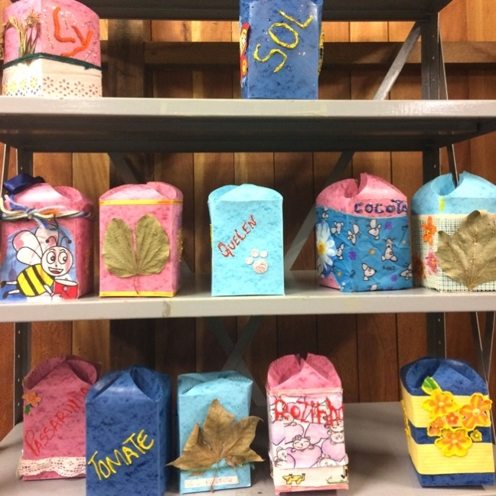
Source: researchers' personal archive

A writer-professor said that the celebration of literature – and, we would state in this case, fiction – is the possibility that we have to mess with the files, playing in the face of oblivion, shuffling memories (MONTEIRO, 2018). He also stated that memory is the major theme of politics; and when returning to Ricardo Piglia, he launched an important question that sets the background of our meetings in the Atelier: “how to deal with the voice of the deceased, / how to reconfigure the narratives and write the story that went untold?”.
Over time, the Garden of Stories Atelier took some detours along the corridors. Our stand had to leave the small wooden house that was in the hospital's garden. In early 2018, we heard that we would need to leave the space with the utmost urgency, as it was in the process of being demolished to make way for a new building. Our first reaction was one of immense frustration, as we did not agree that a place destined for culture should be demolished, and as there was a whole history in danger of falling into oblivion. We had an intense desire to stop the urgencies and put the brakes on the feeling of dismantling that we felt was happening in various spheres within the country. However, there was little we could do about the imperatives and demands coming from the institution. We realized that it would be interesting to reclaim the hospital corridors, to get lost in the labyrinths and find another space that could welcome our intervention.
After some articulations with the Sector team and the hospital management, we managed to secure a small room – which was not exactly inside the hospital, but a little closer to the Sector. We decided, therefore, that the workshop with the boxes/files could give way to another one, seeing as we were in a new room and in a new context, but an activity that shared equally the narrative, the speech and the fiction. We would start embroidering a towel amongst company, as we had done previously in other experiences at parties and meetings promoted by the community health team, still in the years 2015 and 2016, in partnership with the project Bordado Inventado na Praça (Embroidery Created in the Square).

3 MBROIDERING A TOWEL IN THE HOSPITAL: TO WRITE MEMORIES

In the first half of 2018, we invited patients to freely embroider their stories with thread and needle on a large towel spread over a hospital stretcher. The idea was that the towel was a pretext, a device for the availability of being together around an action, weaving stories; that the towel was a common fabric, capable of offering a surface for the memories to be inscribed in. A way, perhaps, for the pain, meant only as organic, to be shifted into another register of meaning, a more symbolic one. The towel as a surface of passage, which offers a place for the singularity of stories to be shared, narrated and reframed (Figure 3).

Figure 3 - Beginning of the embroidered towel
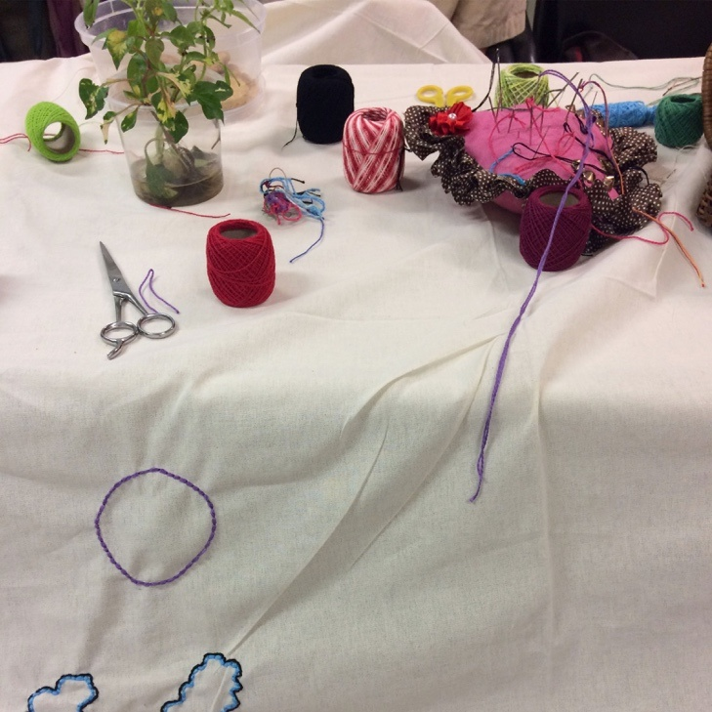
Source: researchers' personal archive

We opened a sewing box in the hospital, an unusual work object for such a context; however, we believe, like Benjamin (2000), that it could be destined to another type of task that amounts not only to plain sewing, but could be a thread trigger that engages memory, hearing and speech, an artisanal making that opens another time for conversation; a way of establishing, with patients diagnosed with chronic pain, a space in which their stories and memories have an extra place for recording and symbolization.
In dealing with chronic pain, one of the ways of contributing to the treatment seems to concern the opening of a field for the narratives to have a space, wagering that they carry the power to promote subjective displacements. The use of fiction is a way of supporting anguish, assisting in naming what maybe cannot be said yet. Chronic pain is a diagnosis that arises with fibromyalgia, which may or may not be associated with depression. The guidelines for pain care, in the country, attest that chronic pain does not present itself only as an extension of acute pain, which arises over time, but, rather, as a complex picture that involves issues seen as “total pain”, which are related to physical, emotional and behavioral pain, including among its causes biological, psychological and sociocultural variables (BRASIL, 1987). Pain, chronic in some way, can operate as a constituent element of a given existence, to the point that it may be the only element to bond with the other. We work with the hypothesis that in the experience of chronic pain there is a certain interwoven silencing that, as it does not find a place to express itself with words, gains expression through the body. This hypothesis accompanies the first studies by Freud (1895/1995), in which the symptom is proposed as a manifestation of an unspoken word. In the Project for a scientific psychology, Freud (1895/1995) situates the body in which physical pain is inscribed as an erogenous body, a body that, when invested by the libido of the ego, becomes a self-body. This inseparability between self and body implies the following proposition: what cannot be enunciated by the self can be heard through the body, as well as all bodily discomfort claims to be signified by the self. This inextricable self-body relationship allowed Freud to propose a speech therapy, capable of producing effects on the body.
The initiative of the embroidery originates from this perspective: the expansion of the narrative, of the conditions to express a malaise, can affect the body, even when that malaise arises, at first, only as physical pain. And these conditions can be extended through the establishing of a space for the circulation of stories - fabricated or real, about oneself or about the world, a field that in this space we call fiction. We emphasize, with Lacan (1959-1960/1997), that reality is not the opposite of illusory or fictional; on the contrary, for psychoanalysis, the truth of each subject, singularity, lies precisely in the possibility of the fictional construction of a life.
While embroidering, the subjects are inscribing and writing words and drawings on the towel. Sometimes they are facts and events of life, other times they are stories that appear in the presence or something that circulates during the day of the meeting. There is an elaboration of shapes that form a body in the communal fabric. The embroidery is free and does not require the knowledge of specific stitches or seams beforehand, anyone with a story to tell is a potential agent of writing with threads. As Figures 4, 5 and 6 reveal, diversity makes up the body-fabric that operates a large memory record of a given time.

Figure 4 – Embroidered writing on the towel
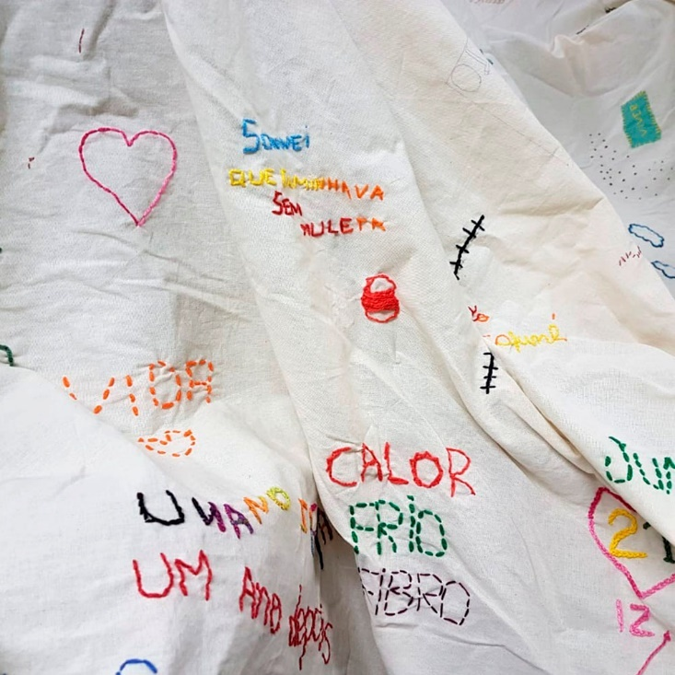
Source: researchers' personal archive

Figure 5 – Embroidered writing on the towel
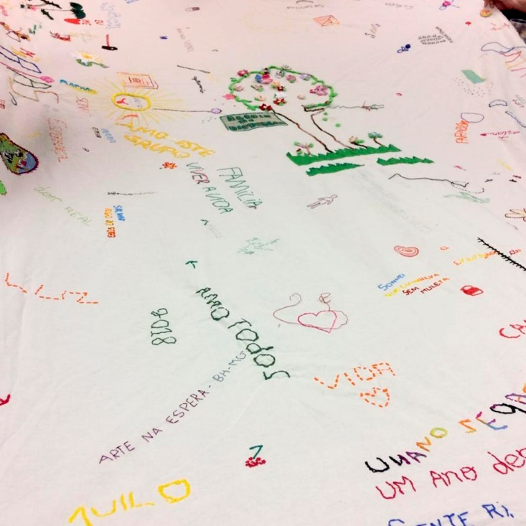
Source: researchers' personal archive

Figure 6 – Embroidered writing on the towel
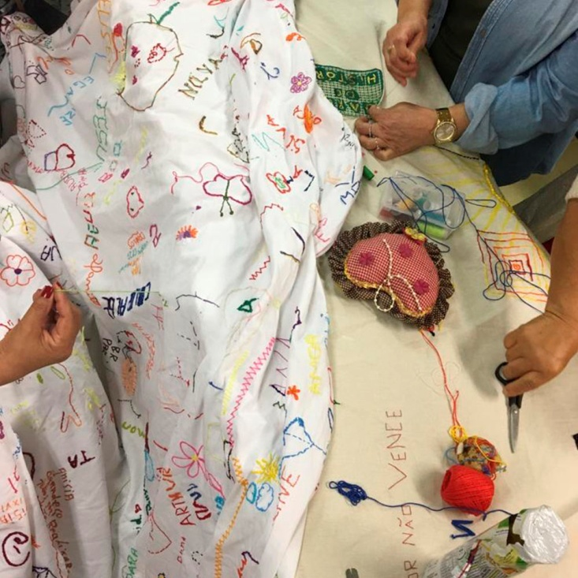
Source: researchers' personal archive

This way of operating has its perspective stemming from the field of art, especially in the theoretical conceptions of Contextual Art, formulated by Paul Ardenne, who thinks of the context as an essential assumption when proposing an intervention. Paul Ardenne (2004) states that it is from the context that the work elements emerge, and reminds us that the word “context” comes from the Latin contextus, from contextere, to weave with. Thus, for this author, Contextual Art groups together creations that anchor themselves in the circumstances of the environment and are concerned with weaving with reality, that is, there is a direct exchange with what they propose with the demands of the place and the people that constitute it. It is the art of action, presence and affirmation, linked to a concrete reality to which the artist/researcher is attached, not properly constituting an isolated object that will take place in an institutional space, such as museums or cultural centers. It is the type of action that is actively inserted in the social fabric, aiming at the invention and transformation of micro-realities, where they operate in co-creation processes.
When we thought about an intervention with embroidery inside the hospital, we already had some practice with this type of action in other places within the city and had an array of interesting experiences with the words that could be triggered by the embroidery. However, in the hospital, unlike in the street context, the intervention originated from very specific characteristics: we initially embroidered on a stretcher (Figure 7), the only prop available in the room, which served as a table. This scene composed of the stretcher, needles and threads represented another scene that is quite common at the institution, and we often see patients playfully emulating a surgical table, with threads and needles sewing a body-fabric.

Figure 7 – Embroidery towel on top of our table/hospital stretcher
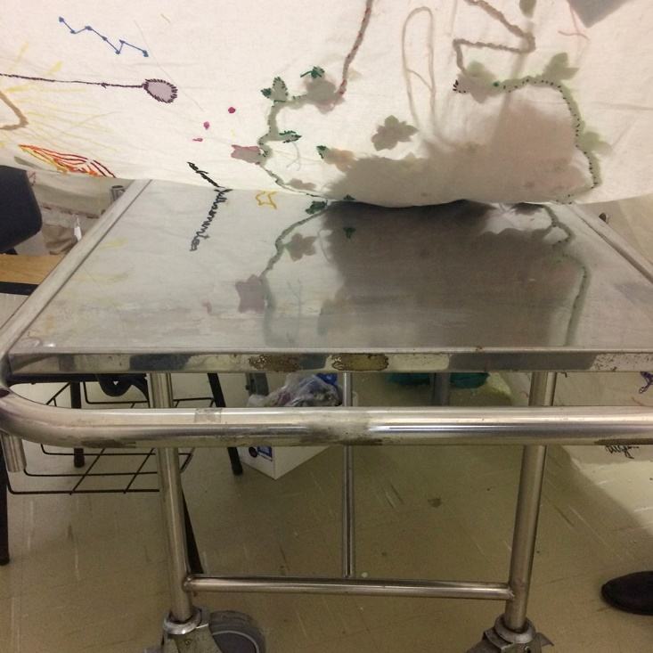
Source: researchers' personal archive

As the needles rise and fall, the words spin. Hands intertwine and the body struggles for a place on the towel. The spools and threads color the stretcher-table at the same time that words and drawings mark the cloth. The trail left by the needles denounces a certain discontinuity: “a small scar on the fabrics” (RICKES, 2006 p. 17). Sewing, writing, memory. The work with fiction and fixation happens and, when embroidering on the towel – and being embroidered by it – there is an opening of the possibility of tracing a narrative, of being the subject of one's own experience. Kehl (2006) recalls that storytelling is like a stage, where one can stage a fantasy and broaden thinking. It is where opportunities are enabled to move, from the body to the speech, the most varied questions, naming that which, without a name, would only remain an anguishing and paralyzing presence for the subject. Somehow, embroidering on a towel in the hospital triggers the act of storytelling. The word circulates and provides an opening, a zone in which memory is built at the very moment in which it is narrated; hence the importance of weaving work in this space that is a threshold: between health, psychoanalysis and art.

FINAL POINTS: THE HORIZONTALITY OF KNOWLEDGE
Our bet with the intervention, and also research hypothesis, was that the insertion of the tablecloth and the shared embroidery could offer conditions for the possibility of passage: allowing a shift of the body as the only medium for recording a silent and repetitive pain, always enunciated as chronic, for other ways of narrating and creating bonds with life. Making the time and space so that this shift could take place, without the urgency of a cure or the emergency of total medical knowledge, resulted in the shape of what was the Garden of Stories Atelier. A shape that the participants themselves made up over time, offering clues about how we could work as a group. The success of the Atelier with the participants and the assisting multidisciplinary team, as well as the testimonies gathered from them in the early years of the research, allowed us not only to confirm our hypothesis and affirm that the narratives have a fundamental role in the treatment processes and in humanized care, but to also expand the project's partnership with the hospital.
The attendees of the Atelier constantly reported on the importance of the group in their lives and, even when also engaging in other spaces of a more therapeutic character, spoke of a fundamental element in the research space: “Here we are the ones telling stories ... And you want to listen!”. On the other hand, the medical team would ask us quite often: “What happens there in the group? Is it magic?”. Tying the threads on these apparently opposite sides, doctor and patient, happened as an effect of the research work itself. When the Atelier was about to complete the first year of its existence, the participants organized a celebratory party and previously invited the entire multidisciplinary team (Figure 8). Strategically, the party was held in a corridor right in front of the door where the team would assemble weekly for a “scientific meeting” (Figure 9). As they left the meeting, they were immediately at the party and were invited to embroider.

Figure 8 – Planning of the one-year party
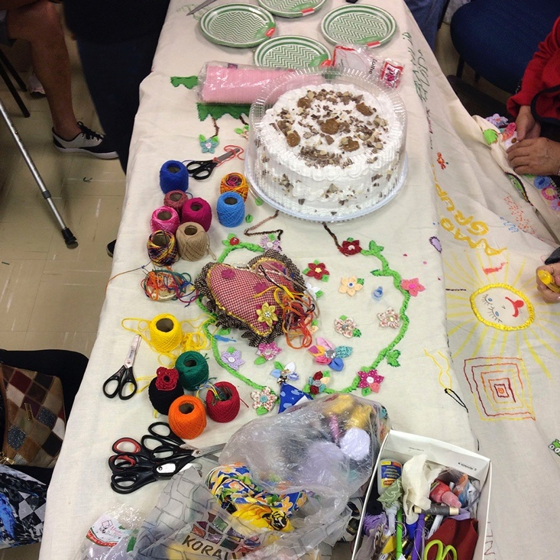
Source: researchers' personal archive

Figure 9 – The one-year party and embroidery on the corridor
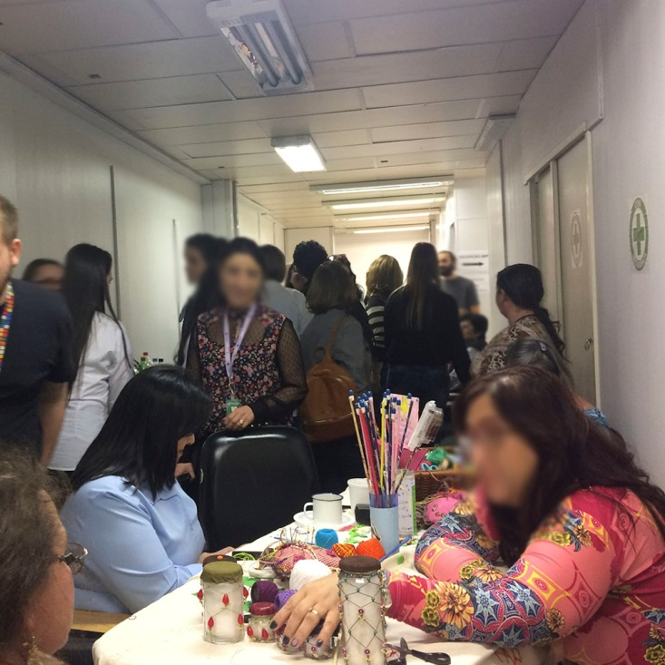
Source: researchers' personal archive

Doctors, secretaries, pastor, psychologists, interns and residents of the Sector gathered around the carefully arranged table for the embroidery. Many of them were excited about the staged scene and about the invitation made by the participants, who conveyed the same care and remarks with which they started on the towel weaving: “Leave your mark here!”, “You don't need to know how to embroider!”. Pills with poems inside were distributed by the patients, confirming, for the research, the power of the work with words, while the needles, threads and space in the towel were disputed by the newcomers of the meeting, called “scientific”. On an uncertain threshold, between scientific and experience-based knowledge, the time of urgencies was distanced and, for a few hours, for those looking at the scene from an outsider's perspective, it was impossible to distinguish between those on the research team, those belonging to the hospital staff and those who were patients: there, gathered around the towel, with the ins and outs of the needles, no one was more knowledgeable than anyone, they were all surgeons of their own destinies.

REFERENCES

ARDENE, P. Un art contextuel: création artistique en milieu urbain, en situation, d’intervention, de participation. Paris: Flammarion, 2004.

BENJAMIN, W. Rua de mão única. Trad. Paulo Sérgio Rouanet. São Paulo: Brasiliense, 2000. (Obras escolhidas, v. 2)

______. Passagens. Belo Horizonte: Editora UFMG, 2018.

BRASIL. Ministério da Saúde. Divisão Nacional de Vigilância Sanitária de Alimentos. Portaria nº 1, de 04 de abril de 1986. In: ASSOCIAÇÃO BRASILEIRA DAS INDÚSTRIAS DE ALIMENTAÇÃO. Compêndio da legislação de alimentos. São Paulo: ABIA, 1987. v. 1A.

CALVINO, I. Seis propostas para o próximo milênio: lições americanas. São Paulo: Companhia das Letras, 1990.

CUNHA, C. F.; VIANA, O. L.; GUIMARAES, P. R.; REIS, R.; IANNARELLI, R.; AMARAL, S. T.; GOMES, T. M.; OLIVEIRA, T. C. P. R. de. Arte na espera: tecendo uma rede de acolhimento para o adolescente e para a família. Adolescência & Saúde, v. 12, supl. 1, p. 44-51, mar. 2015. Available in: http://adolescenciaesaude.com/detalhe_artigo.asp?id=490. Accessed on: 21 jan. 2020.

FREUD, S. (1912). Recomendações aos médicos que exercem a psicanálise. In: ______. Edição standard brasileira das obras completas de Sigmund Freud, v. XII. Imago: Rio de Janeiro, 2006.

KEHL, M. R. Prefácio. In: CORSO, D. L. & CORSO, M. Fadas no divã: psicanálise nas histórias infantis. Porto Alegre: Artmed, 2006.

LACAN, J. (1956-1957). O seminário, livro 4: A relação de objeto. Rio de Janeiro: Jorge Zahar, 1995.

______. (1959-1960). O seminário, livro 7: A ética da psicanálise. Rio de Janeiro: Jorge Zahar, 1997.

MONTEIRO, P. M. Literatura e respiração: Ricardo Piglia (1940-2017). Available in: https://meiramonteiro.com/literatura-e-respiracao-ricardo-piglia-1940-2017. Accessed on: 10 nov. 2018.

RICKES, S. M. No fio da palavra. Organon, v. 40/41, p. 17-28, 2006.

TAVARES, G. M. Breves notas sobre as ligações (Llansol, Molder e Zambrano). Lisboa: Relógio D’Água, 2009.

This essay is an edited and expanded review of the text “A sewing box in the hospital: threads and needles to embroider stories”, presented at the 1st Walter Benjamin International Congress: barbarism and ethical memory, in the year 2018.
The Wagon or the Store of Travelling Stories, a project coordinated by Artist Ana Flávia Baldisserotto. More at: http://www.historiasambulantes.com.br/.
Palliative Care are actions of a multidisciplinary team that aims to improve the quality of life of patients and family members in the face of life-threatening diseases, promoting pain control and symptom relief, devoting their attention in psychic, spiritual and social supports, which must be present from the diagnosis to the end of life.
The collective The Wagon is a group of people who gather around the project Store of Travelling Stories – The Wagon. More in: http://www.historiasambulantes.com.br/.
The Hilo-Fio Network is an open set of collaborative actions and urban interventions that have in common the practice of collective embroidery on large table cloths. By offering themselves as free spaces for collective construction, the tablecloths, stretched out together with the invitation to weave-with, operate small deviations in the daily logic of the cities and regions where they operate. By welcoming and supporting the diversity of voices that make up the social fabric, these actions have put into circulation non-hegemonic knowledge and ways of inhabiting public spaces that unfold in questionings about the notions of authorship, property and the common good.
Bordado Inventado na Praça (Embroidery Created in the Square) is a collaborative project with contextual emphasis, aimed at building social and creative bonds with the community of Lupicínio Rodrigues Square, located in the district Menino Deus, in Porto Alegre. The work methodology foresees three times and dimensions of action: the embroidery wheels, the parties and the cine-sheet. More in: www.bordadonapraca.com.br.

